Dynamic Information Section with Page Title

# Description

Get the page title & show the information of respective pages if information is available else highlight the no information message with page title.

You can add information related to page, steps related to functionality of the page, format the text, attach videos, images, etc.

JS added to get the page title.

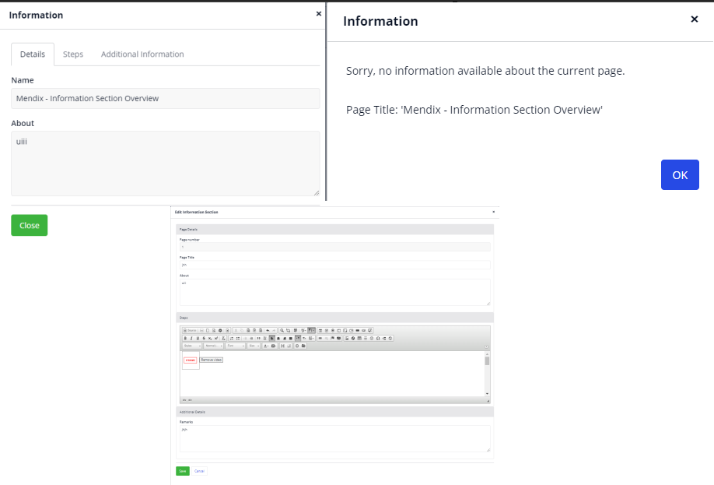

# Typical Usage Scenario

To explain the functionality of the current page, so that new user easily gets to know from where or how to start.

# Prerequisites

* CKEditor For Mendix

# Features and Limitations

* For dynamic configuration, add the information link in your page layout or as per your requirement.
* Here we have added an information section that will work according to page title, so the user can see information related to current page or know about functionality & steps to execute.

# Dependencies

* CKEditor For Mendix widget

# Installation

1. Download the widget from marketplace.
2. From ‘Information Overview page’ copy the icon (i) and place it on your suitable layouts, sections, pages, etc.



1. Click on New or Edit button and configure the following properties in the information section -

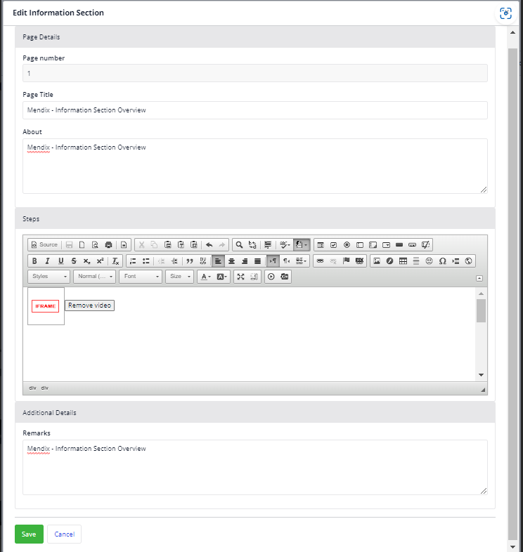

## Call the section in the below manner, here user is using in page layout:

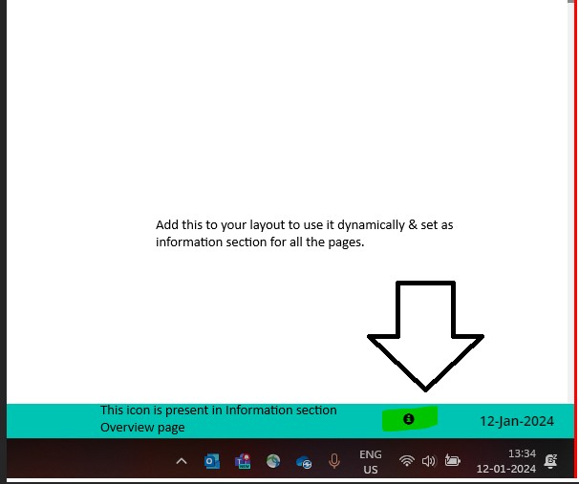

1. **Click on icon: i. If information section is not available, show the page title with information.**

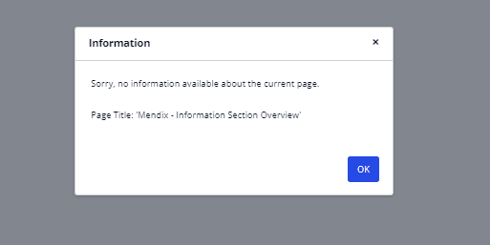

## Click on icon: i. If information section is available, show the below details

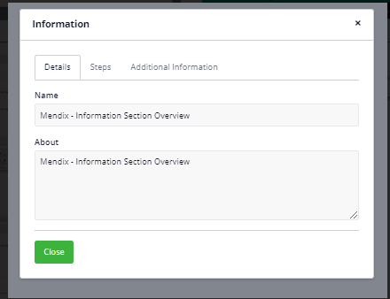

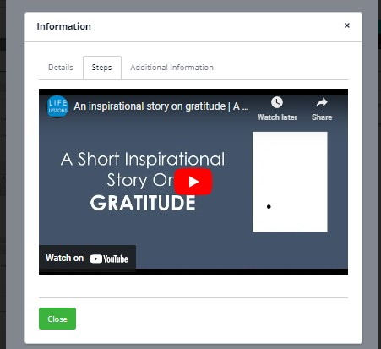

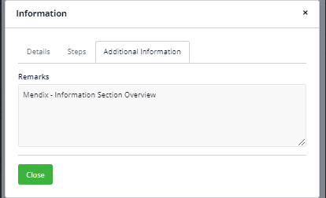

**Configuration: NA Category: Module Subcategory: All**

## Visibility: Public Marketplace Studio Pro Version: 9.21.3